// Practice Problems
🟢 Level 1 — Must Do
Q1. Print all elements of an ArrayList
Given an ArrayList of integers, print every element.
Example:
Input: [10, 20, 30, 40]
Output: 10 20 30 40

Q2. Find the maximum element
Input: [10, 45, 23, 67, 12]
Output: 67

Q3. Find the minimum element
Input: [10, 45, 23, 67, 12]
Output: 10

Q4. Find the sum of all elements
Input: [10, 20, 30, 40]
Output: 100

Q5. Find the average of elements
Input: [10, 20, 30, 40]
Output: 25.0

Q6. Search an element
Given an ArrayList and a key, check whether the key exists.
Input: [10, 20, 30, 40], key = 30
Output: Found
Practice both:
list.contains(key)
and manually using a loop.

Q7. Count even and odd numbers
Input: [10, 15, 20, 25, 30]
Output:
Even = 3
Odd = 2

Q8. Count positive, negative and zero
Input: [10, -5, 0, 20, -3, 0]
Output:
Positive = 2
Negative = 2
Zero = 2

🟡 Level 2 — Very Important
Q9. Remove a particular element
Input: [10, 20, 30, 20, 40]
Remove: 20

Output: [10, 30, 20, 40]
Understand the difference between:
list.remove(2); // removes by INDEX
list.remove(Integer.valueOf(20)); // removes VALUE
⭐ This is a common Java interview trap.

Q10. Remove all occurrences of an element
Input: [10, 20, 30, 20, 40, 20]
Remove: 20

Output: [10, 30, 40]

Q11. Reverse an ArrayList
Input: [10, 20, 30, 40]
Output: [40, 30, 20, 10]
Try it first without Collections.reverse().

Q12. Find duplicate elements
Input: [10, 20, 30, 20, 40, 10]
Output: 10 20
⭐ Very important for placement coding.

Q13. Find frequency of each element
Input: [10, 20, 10, 30, 20, 10]

Output:
10 → 3
20 → 2
30 → 1
This also prepares you for HashMap, which you'll use heavily later.

Q14. Find the second largest element
Input: [10, 50, 30, 80, 40]

Output: 50
Try without sorting first.

Q15. Find the second smallest element
Input: [10, 50, 30, 80, 40]

Output: 30

🟠 Level 3 — Coding Round Style
Q16. Sort an ArrayList in ascending order
Input: [40, 10, 30, 20]
Output: [10, 20, 30, 40]
First try:
Collections.sort(list);
Then implement sorting manually.

Q17. Sort in descending order
Input: [40, 10, 30, 20]
Output: [40, 30, 20, 10]
i--
Currently:
i = 0
We do:
i--;
So:
i = -1
Then the for loop's update executes:
i++
Therefore:
-1 + 1 = 0
Q18. Find common elements between two ArrayLists
A = [10, 20, 30, 40]
B = [20, 40, 50, 60]

Output: [20, 40]

Q19. Merge two ArrayLists
A = [10, 20, 30]
B = [40, 50, 60]

Output: [10, 20, 30, 40, 50, 60]

Q20. Remove duplicate elements
Input: [10, 20, 10, 30, 20, 40]

Output: [10, 20, 30, 40]
Try first without HashSet.

🔴 Level 4 — Good for HCL/TCS-style Practice
Q21. Find the first non-repeating element
Input: [10, 20, 10, 30, 20, 40]

Output: 30
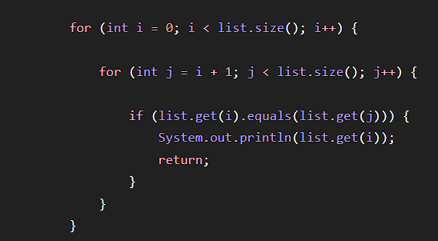
Q22. Find the first repeating element
Input: [10, 20, 30, 20, 40]

Output: 20

Q23. Move all zeros to the end
Input: [0, 10, 0, 20, 30, 0]
Output: [10, 20, 30, 0, 0, 0]
⭐ Very useful array/ArrayList pattern.

Q24. Separate even and odd elements
Input: [10, 15, 20, 25, 30]

Output:
Even: [10, 20, 30]
Odd: [15, 25]

Q25. Find the missing number
Input: [1, 2, 3, 5, 6]

Output: 4

